**Biome Makers Enhances BeCrop Farm with New Tabular View, Expanding Access to Soil Intelligence Data**

**FOR IMMEDIATE RELEASE**

**Davis, CA – September 23rd, 2025 —** Biome Makers, a global agtech company and pioneer in soil microbiome intelligence, today announced the launch of **Tabular View,** a powerful new feature within the BeCrop® Farm platform that makes reviewing and exporting soil health data easier than ever.

The new Tabular View gives BeCrop® Farm users a spreadsheet-style interface to view all of their farm and field-level data in one place. Customers can now explore needs indexes, recommendations and more in a clean, sortable table. This makes it simple to compare results, focus on the metrics that matter most, and move seamlessly between farm- and field-level insights.

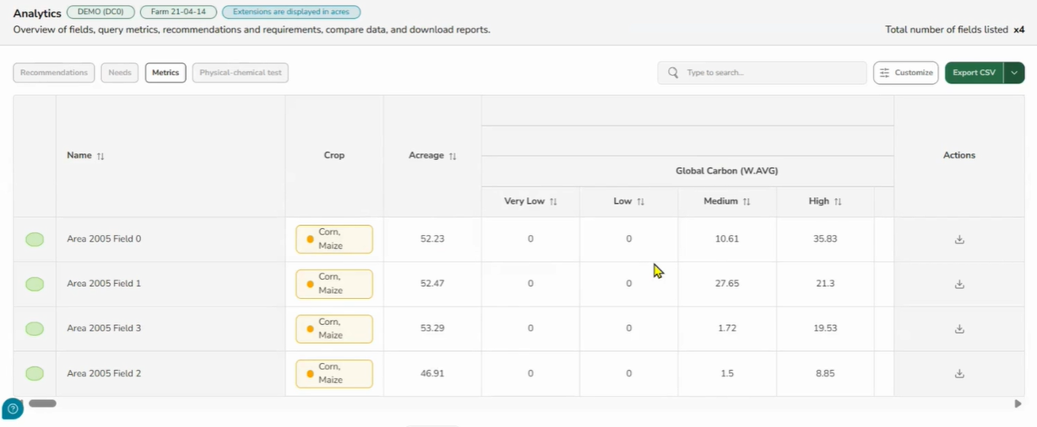

Tabular View also makes BeCrop® Farm data exportable. Customers can now:

* Download CSV files to integrate into farm management software, databases, or custom reports
* Export PDF reports at both farm and field level, complete with summaries, insights, and recommendations

“This feature was designed to make BeCrop data as useful and versatile as possible,” said Alberto Acedo, PhD, Chief Scientific Officer and co-founder of Biome Makers. “It’s a clean and easy way for users to look at and compare their results. They can sort down to the class of results they want to focus on, or view the entire dataset. By making the data downloadable, growers and advisors can study correlations with yield, create their own figures, and combine BeCrop® insights with other farm records to unlock even more value.”

As the world’s leading soil health platform, BeCrop® Farm helps growers, retailers, and advisors turn soil microbiome intelligence into practical, field-ready recommendations. With the addition of Tabular View, Biome Makers is expanding the ways customers can manage, share, and apply their soil health data to improve decisions and outcomes.

 To experience the new Tabular View firsthand, current BeCrop® Farm users can sign in at <https://portal.becrop.com/>. New users can create an account, add their farm in just a few clicks using integrations with leading platforms, and request a free quote.

**About Biome Makers**Founded in the Bay Area of California in 2015, Biome Makers is one of the foremost global AgTech leaders, setting the standard in soil health with BeCrop® technology. Built on industry-leading soil microbiome and machine learning expertise, Biome Makers connects soil biology to agricultural decision-making to optimize farming practices and reverse the degradation of arable soils. With labs across the globe, customers on six continents, and over 2.2 million acres of land impacted, Biome Makers revitalizes soil functionality and agricultural sustainability worldwide. Learn more at [biomemakers.com](https://www.biomemakers.com).

########